

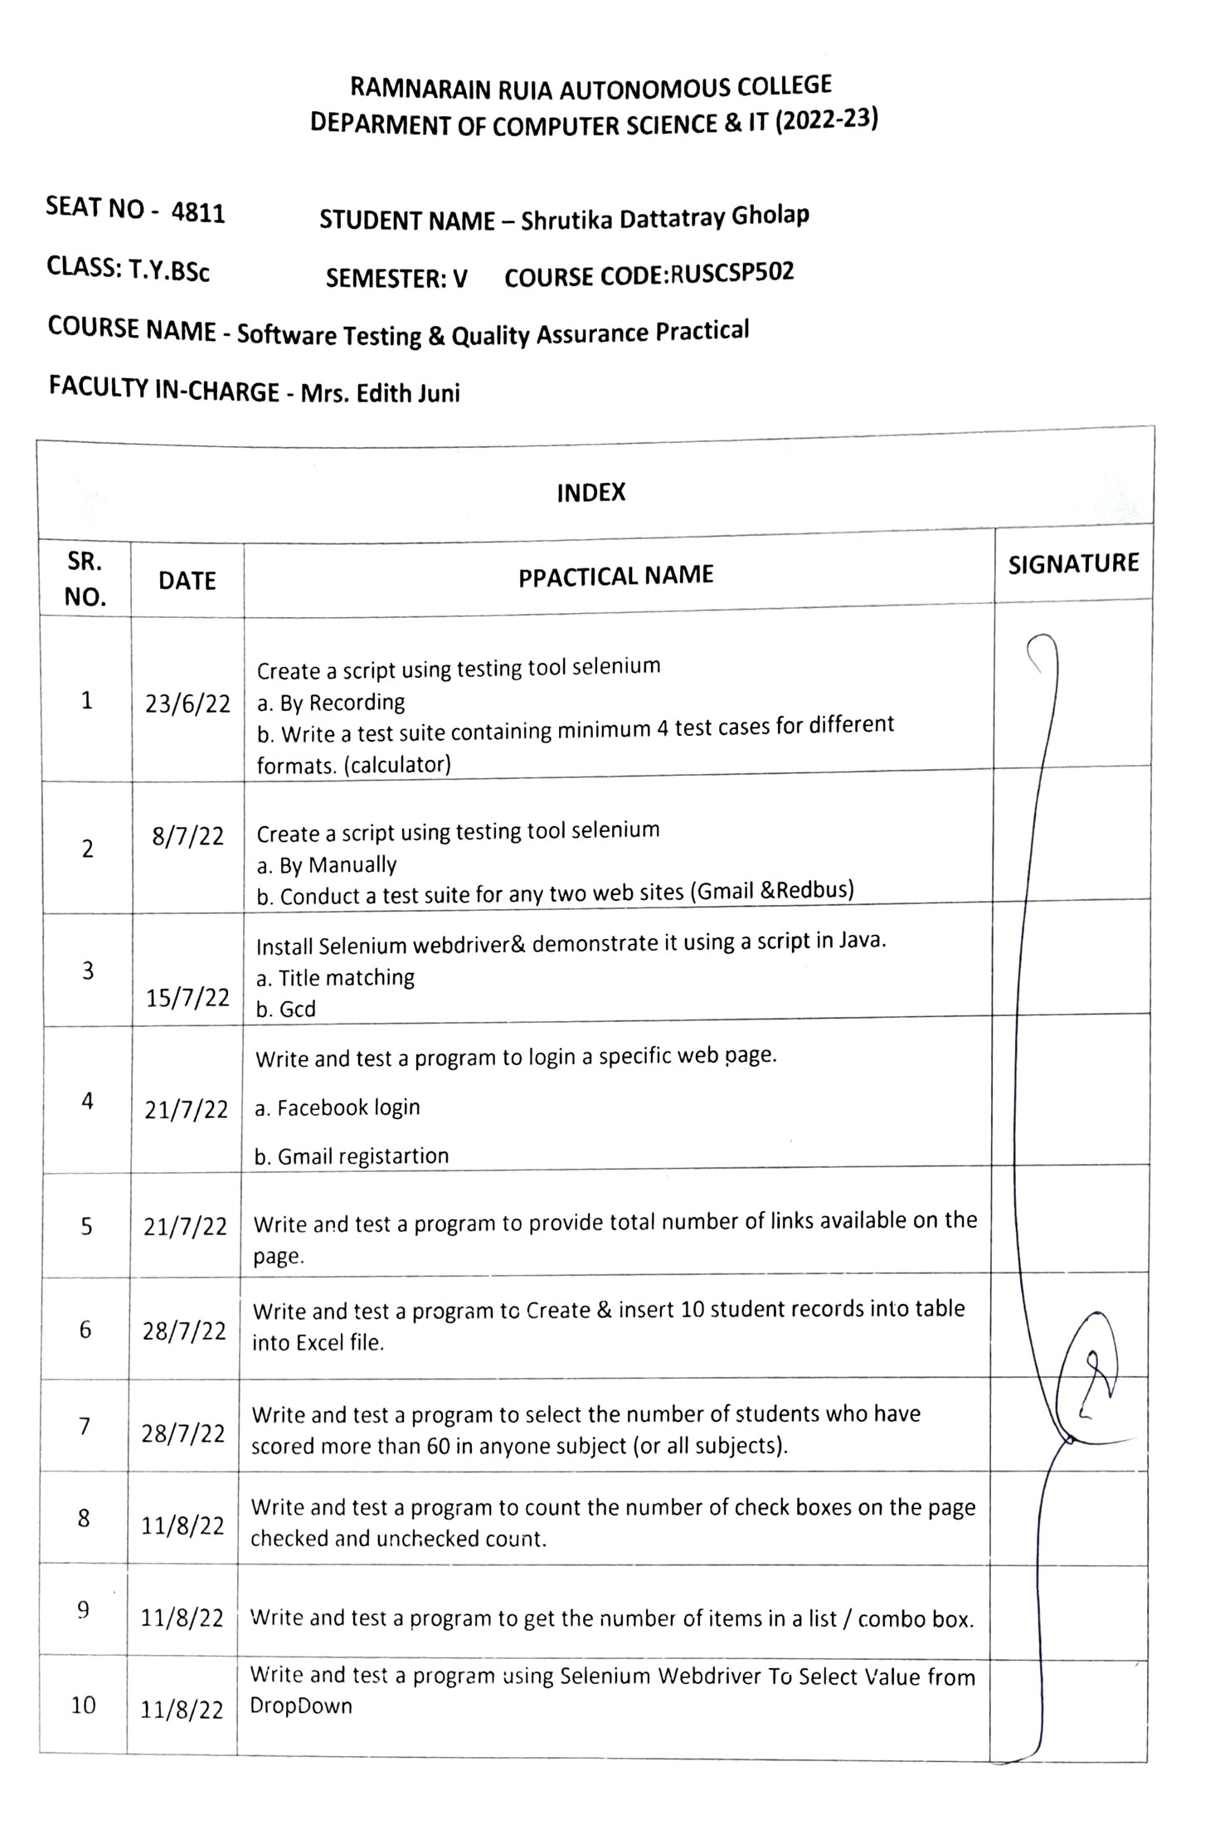

**Practical 1 : Script using testing tool selenium**

a. script using testing tool selenium By Recording  
b. Write a test suite containing minimum 4 test cases for different formats. (calculator)

Opening selenium IDE

Open firefox

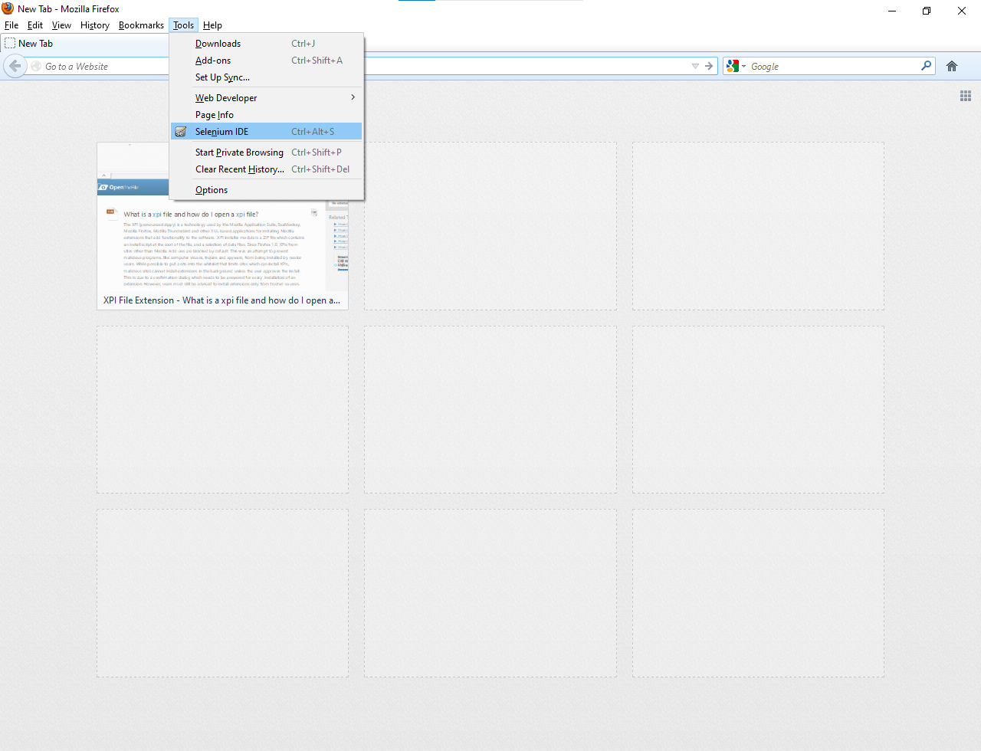

Base URL : url of website

Red button: recording

Play button: to play all test cases (upper left corner)

Cntrl + s : Save test case

File -> new test case : add new test case

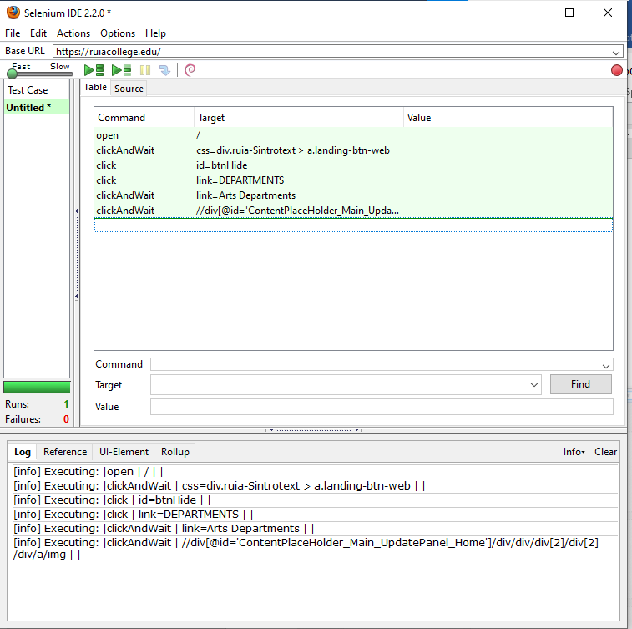



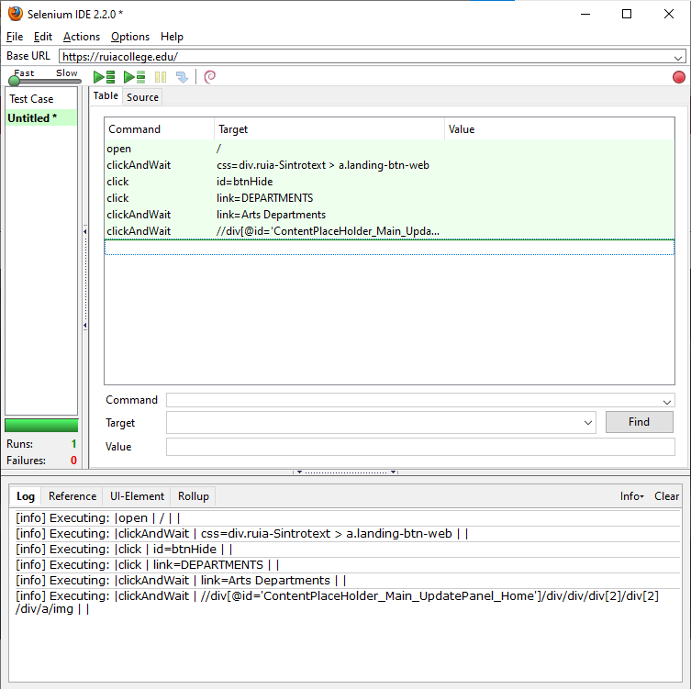

Calculator.html

<!DOCTYPE html>

<html lang="en">

<head>

    <meta charset="UTF-8">

    <meta http-equiv="X-UA-Compatible" content="IE=edge">

    <meta name="viewport" content="width=device-width, initial-scale=1.0">

    <title>Calculator</title>

</head>

<style>

    .container{

        text-align: center;

    }

</style>

<body>

    <div class="container">

        <div class="title">

            <h2>Arithematic Operations</h2>

            <hr>

        </div>

        <br><br>

        <div class="inputs">

            <div class="input1">

                <label for="num1">Number 1 : </label>

                <input type="number" class="num1" id="num1">

            </div>

            <br>

            <div class="input2">

                <label for="num2">Number 2 : </label>

                <input type="number" class="num2" id="num2">

            </div>

            <br>

        </div>

        <br>

        <div class="operations">

            <button class="addBtn" onclick="add()">ADD</button>

            <button class="subBtn" onclick="sub()">SUB</button>

            <button class="mulBtn" onclick="mul()">MUL</button>

            <button class="divBtn" onclick="div()">DIV</button>

        </div>

        <br>

        <div class="result">

            <label for="result">Result : </label>

            <input class="result" type="number" id="result">

        </div>

    </div>

    <script>

        function add(){

            var a =  document.getElementById("num1").value;

            var b =  document.getElementById("num2").value;

            document.getElementById("result").value=parseInt(a) + parseInt(b);;

        }

        function sub(){

            var a =  document.getElementById("num1").value;

            var b =  document.getElementById("num2").value;

            document.getElementById("result").value=parseInt(a) - parseInt(b);;

        }

        function mul(){

            var a =  document.getElementById("num1").value;

            var b =  document.getElementById("num2").value;

            document.getElementById("result").value=parseInt(a) * parseInt(b);;

        }

        function div(){

            var a =  document.getElementById("num1").value;

            var b =  document.getElementById("num2").value;

            document.getElementById("result").value=parseInt(a) / parseInt(b);;

        }

        </script>

</body>

</html>

OUTPUT :

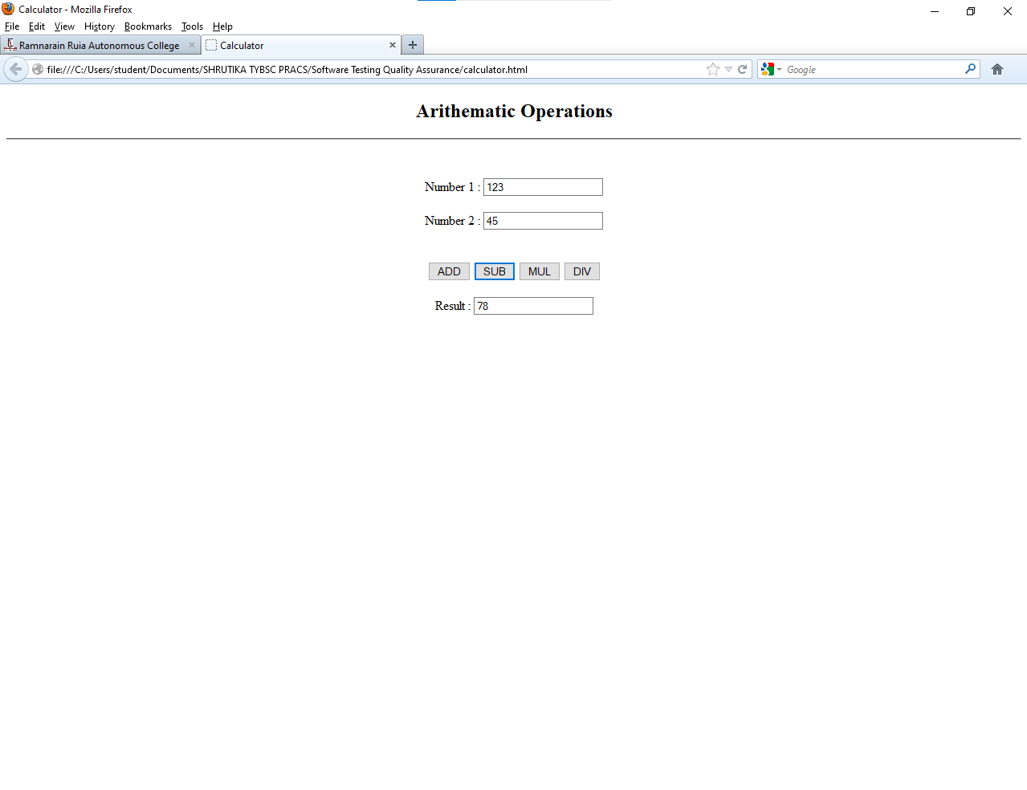

Test Cases

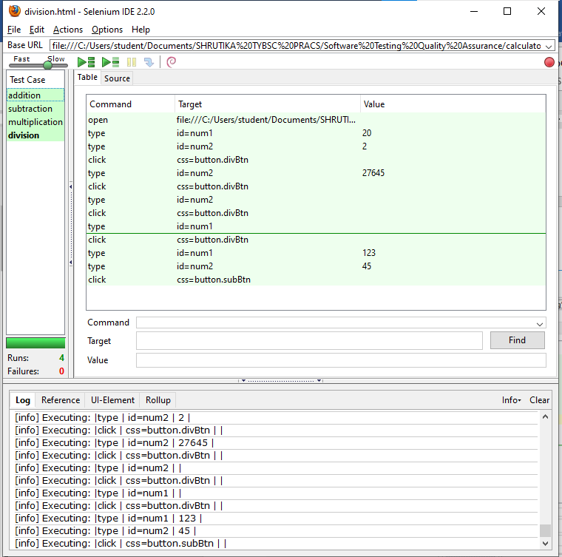

**PRACTICAL 2 : Test case manually**

Typing command manually

1. OPEN

command textbox : open

Target textbox : url of website

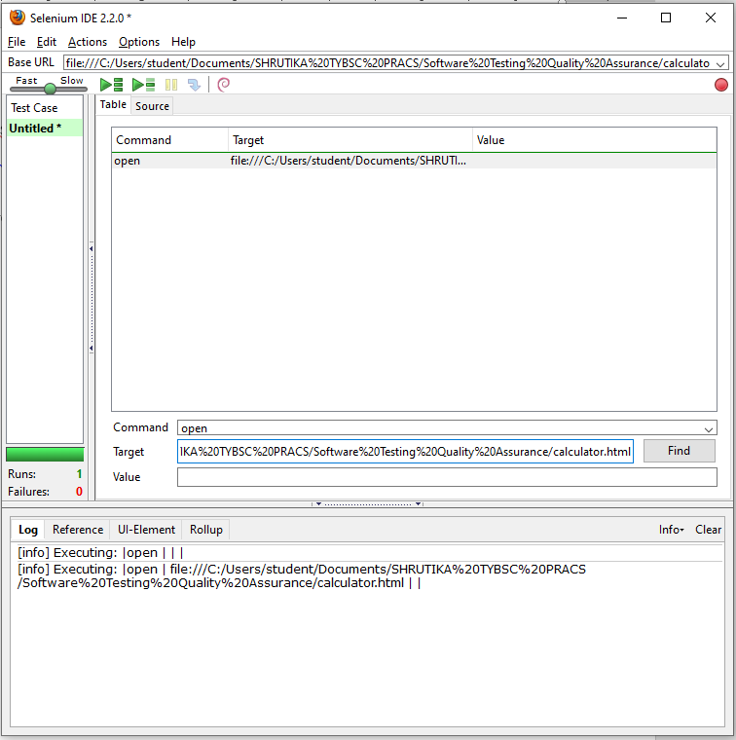

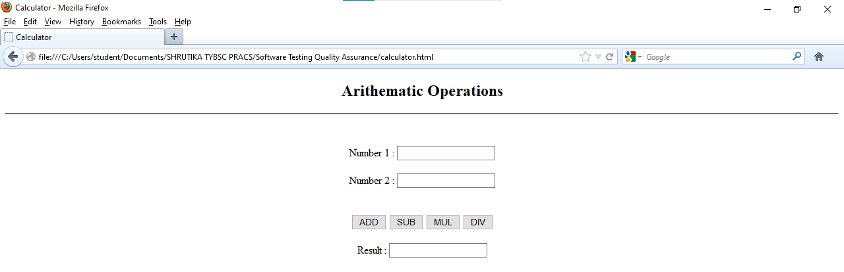

1. CLICK

Command textbox : click

Target textbox : name = n1 [name attr of number1 textbox]

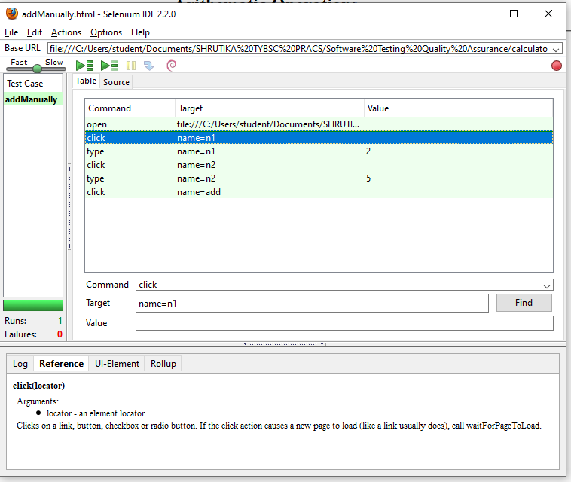

1. TYPE

Command textbox : type

Target textbox : name = n1

Value textbox : 2 [any value]

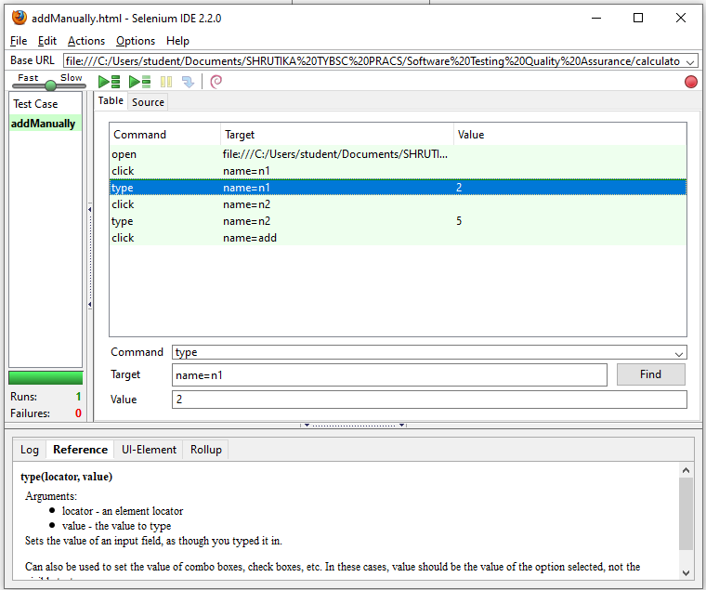

1. Click on play entire test suite button

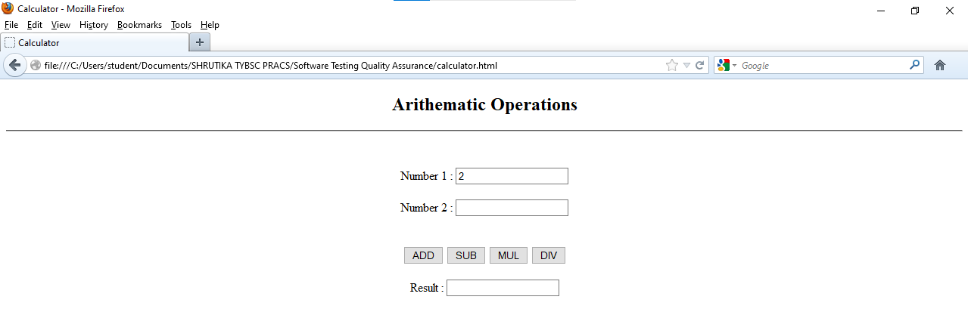

1. Similarly write click , type commands for 2nd textbox

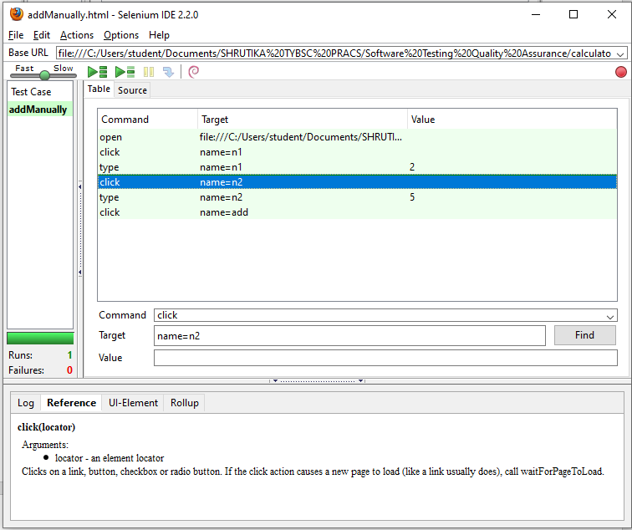

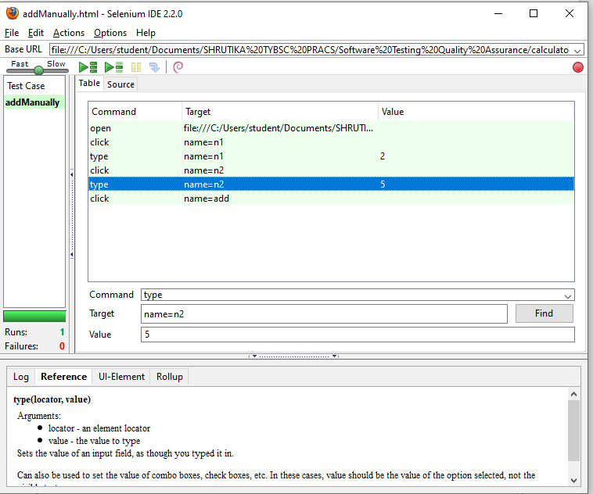

1. For performing addition [click add botton]

Command textbox : click

Target textbox : name = add

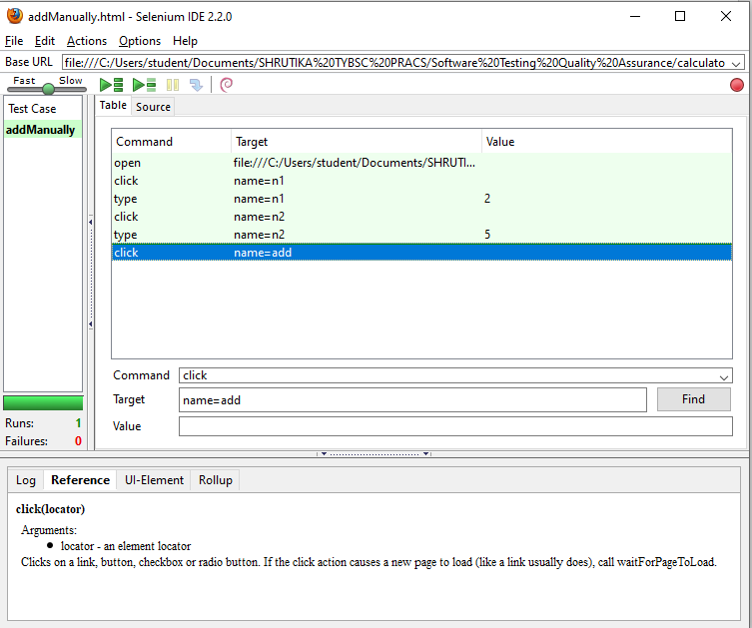

1. Run the test cases

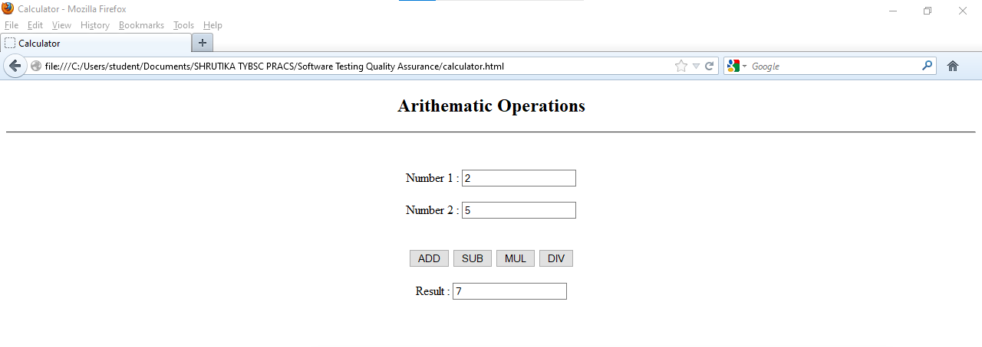

1. Similarly for subtraction

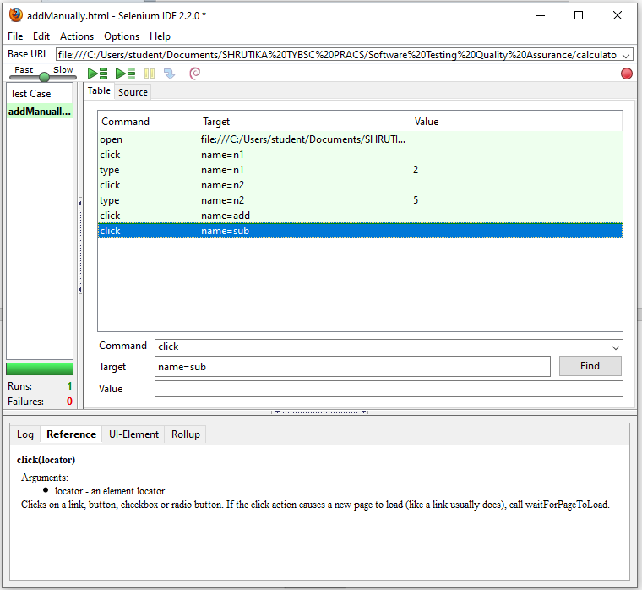

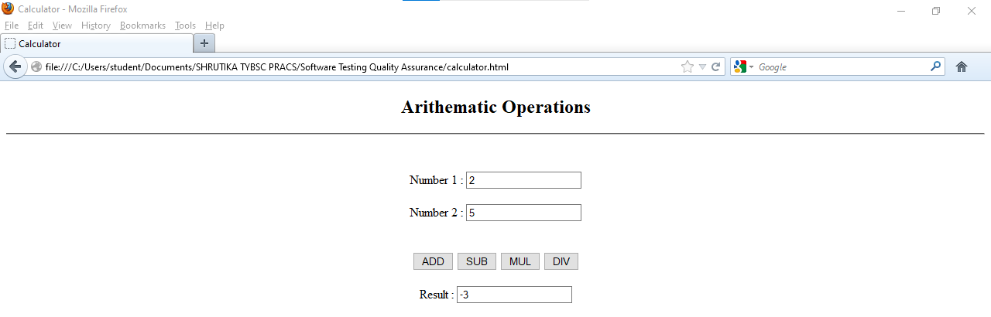

1. Multiplication

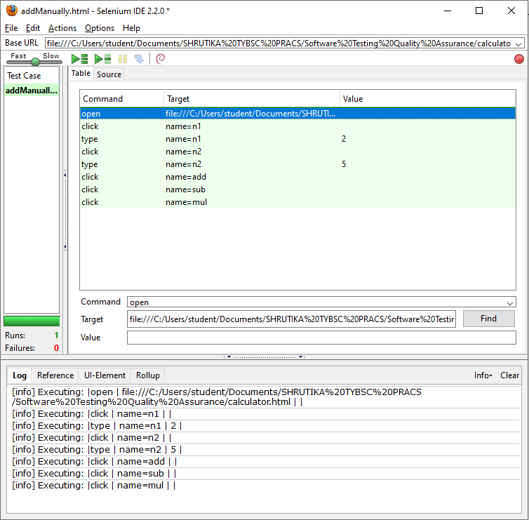

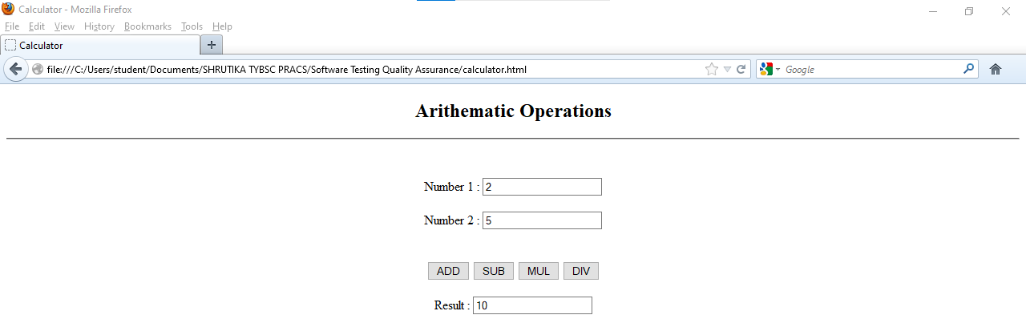

1. Division

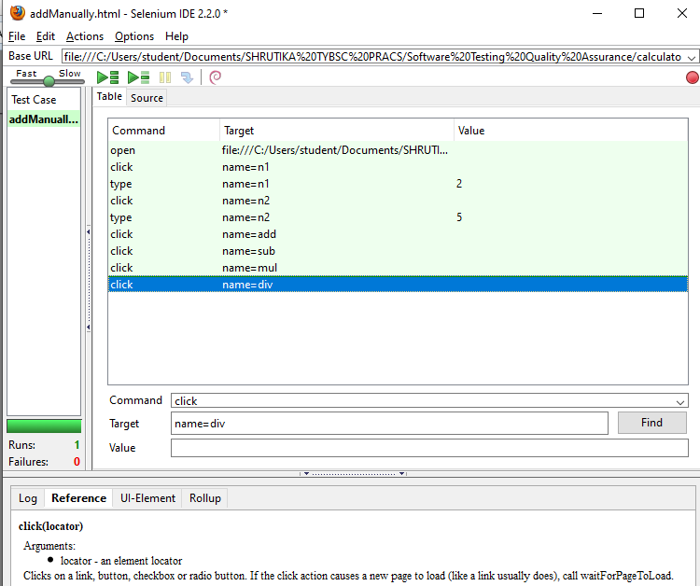

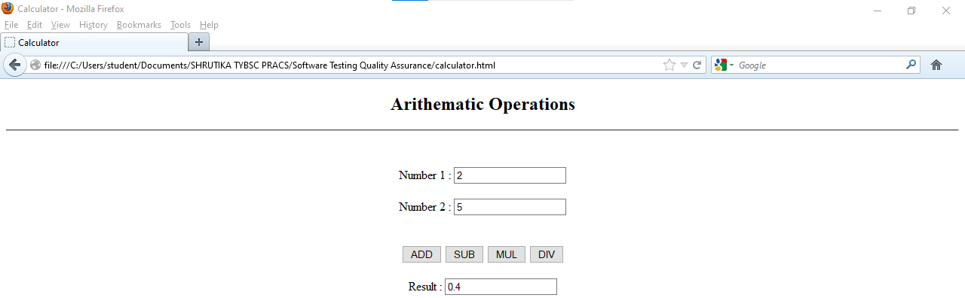

**PRACTICAL 3A : Install Selenium webdriver & demonstrate it using a script in Java.**

a. Title matching  
b. Gcd

Create a java project

Then a package and java class

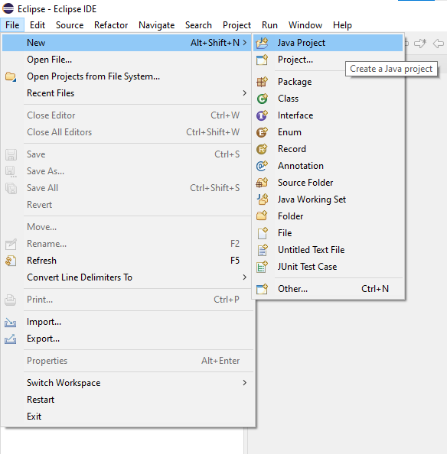

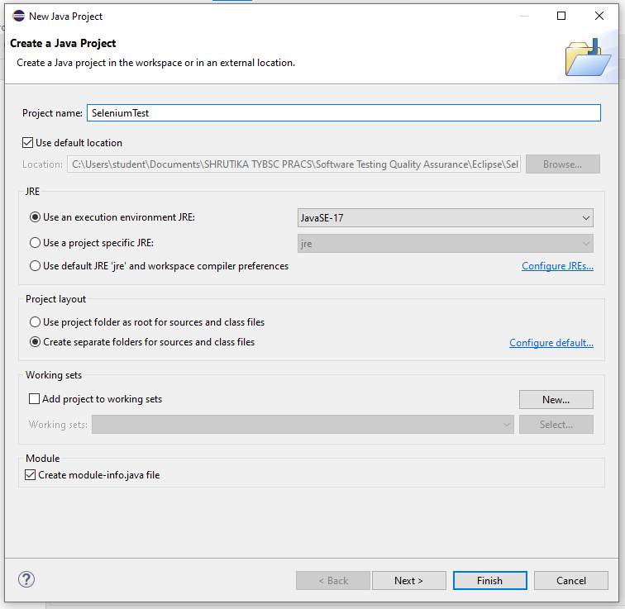

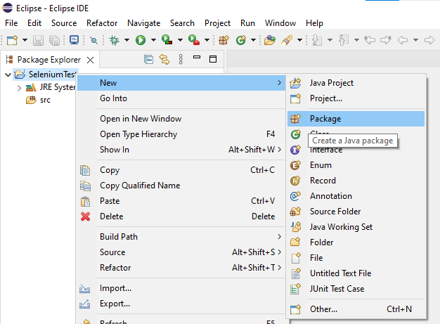

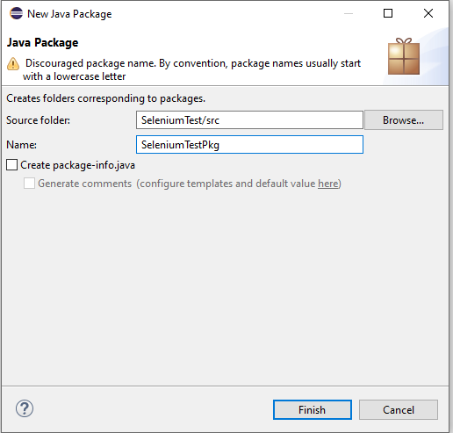

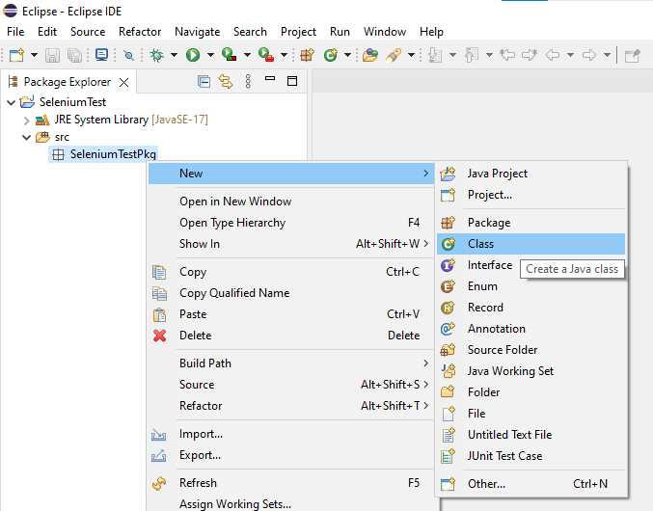

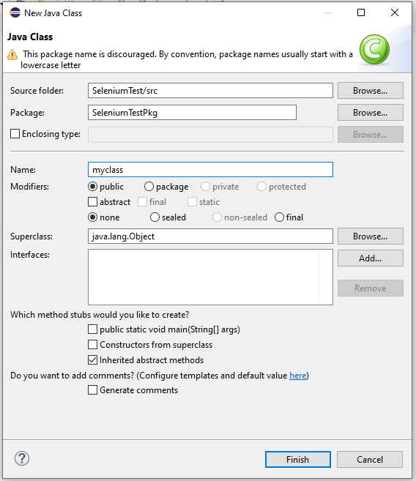

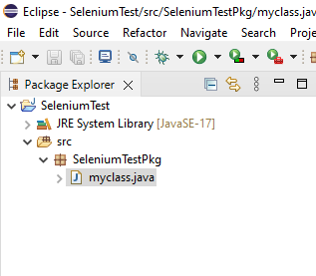

**CODE :**

**package** SeleniumTestPkg;

**import** org.openqa.selenium.WebDriver;

**import** org.openqa.selenium.firefox.FirefoxDriver;

**public** **class** myclass {

**public** **static** **void** main(String[] args) {

        // declaration and instantiation of objects/variables

        WebDriver driver = **new** FirefoxDriver();

        String baseUrl = "file:///C:/Users/student/Documents/SHRUTIKA%20TYBSC%20PRACS/Software%20Testing%20Quality%20Assurance/calculator.html";

        String expectedTitle = "calculator";

        String actualTitle = "";

        // launch Firefox and direct it to the Base URL

        driver.get(baseUrl);

        // get the actual value of the title

        actualTitle = driver.getTitle();

        /*

         * compare the actual title of the page witht the expected one and print

         * the result as "Passed" or "Failed"

        */

**if** (actualTitle.contentEquals(expectedTitle)){

               System.***out***.println("Test Passed!");

        } **else** {

               System.***out***.println("Test Failed");

        }

        //close Firefox

        driver.close();

        // exit the program explicitly

        System.*exit*(0);

   }

}

**OUTPUT :**

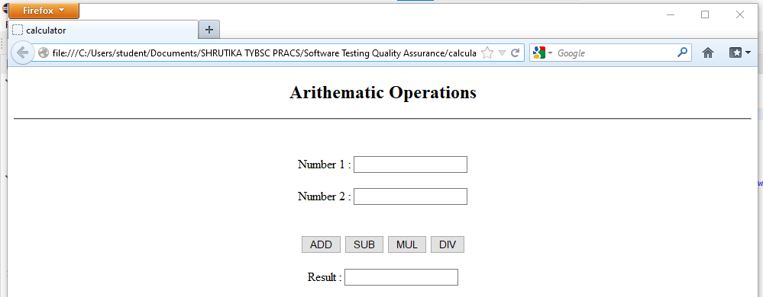

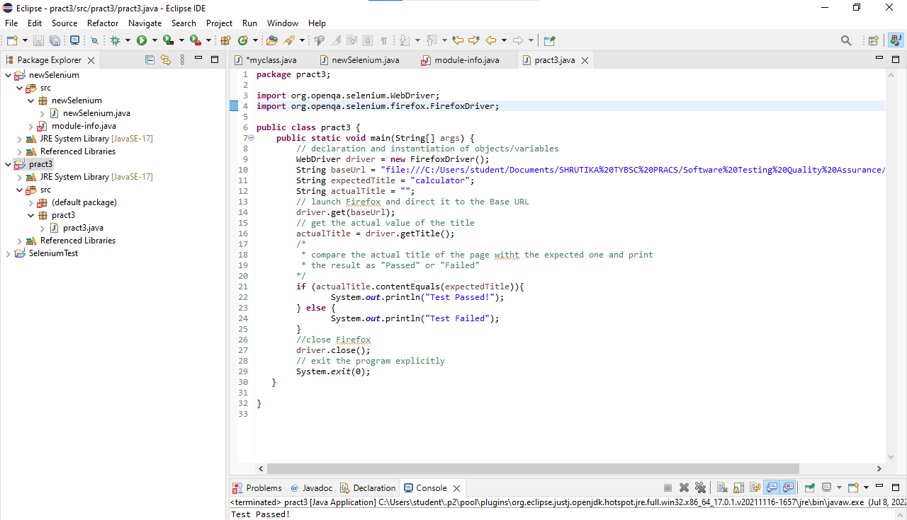

If error comes

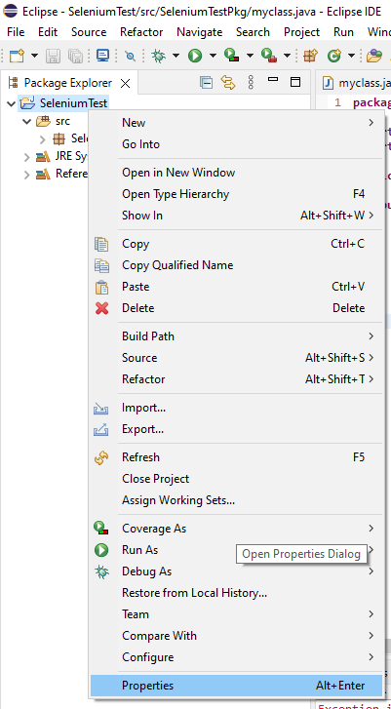

Set java compiler version 1.8

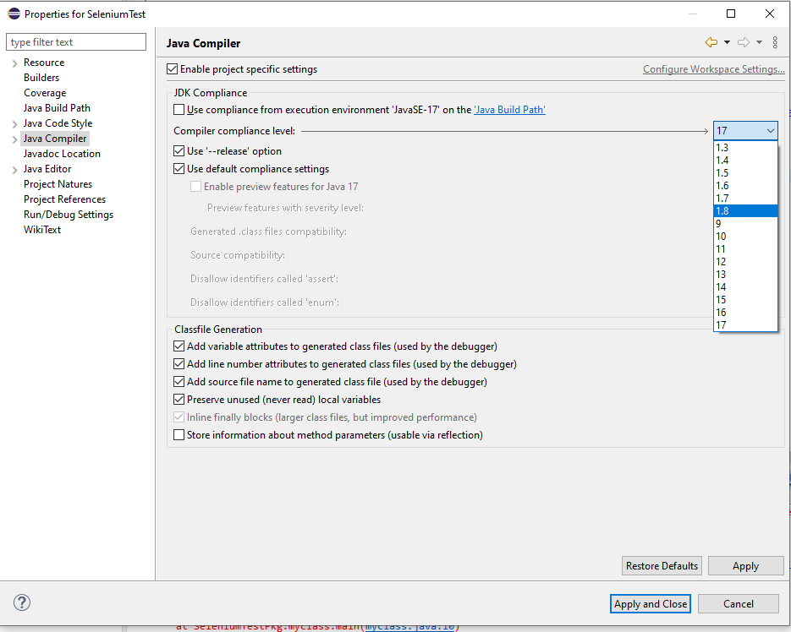

Apply and close

**PRACTICAL 3B : Calculate GCD of two numbers**

1. Write html code to calculate GCD of two numbers

**CODE** :

<!DOCTYPE html>

<html lang="en">

<head>

    <meta charset="UTF-8">

    <meta http-equiv="X-UA-Compatible" content="IE=edge">

    <meta name="viewport" content="width=device-width, initial-scale=1.0">

    <title>GCD calculator</title>

</head>

<style>

    .container{

        text-align: center;

    }

</style>

<body>

    <div class="container">

        <div class="title">

            <h2>Arithematic Operations</h2>

            <hr>

        </div>

        <br><br>

        <div class="inputs">

            <div class="input1">

                <label for="num1">Number 1 : </label>

                <input type="number" class="num1" id="num1" name="n1">

            </div>

            <br>

            <div class="input2">

                <label for="num2">Number 2 : </label>

                <input type="number" class="num2" id="num2" name="n2">

            </div>

            <br>

        </div>

        <br>

        <div class="operations">

            <button class="submit" onclick="gcd()" name="submit">Submit</button>

        </div>

        <br>

        <div class="result">

            <label for="result">GCD is : </label>

            <input class="result" type="number" id="result" name="result">

        </div>

    </div>

    <script>

        function gcd(){

            var a =  document.getElementById("num1").value;

            var b =  document.getElementById("num2").value;

            x = Math.abs(a);

            y = Math.abs(b);

            while(y) {

              var t = y;

              y = x % y;

              x = t;

            }

            document.getElementById("result").value=x;

        }

        </script>

</body>

</html>

1. Write java code in eclipse IDE to insert values in input fields and calculate GCD also print GCD on java console

**CODE**  :

**package** calc;

**import** org.openqa.selenium.By;

**import** org.openqa.selenium.WebDriver;

**import** org.openqa.selenium.firefox.FirefoxDriver;

**import** org.openqa.selenium.remote.DesiredCapabilities ;

**public** **class** gcd {

**static** String *driverpath*="C:\\Selenium\\geckodriver-v0.21.0-win32\\Geckodriver.exe";

**public** **static** WebDriver *driver* ;

**public** **static** **void** main(String args[]) {

System.*setProperty*("webdriver.gecko.driver",*driverpath*);

DesiredCapabilities capabilities = DesiredCapabilities.*firefox*();

capabilities.setCapability("marionette",**true**);

*driver*= **new** FirefoxDriver(capabilities);

*driver*.get("file:///C:/Users/Vaibhav/OneDrive/Documents/PRACTICE/gcd1.html");

*driver*.findElement(By.*name*("n1")).sendKeys("21");

*driver*.findElement(By.*name*("n2")).sendKeys("18");

*driver*.findElement(By.*name*("submit")).click();

String result = *driver*.findElement(By.*name*("result")).getAttribute("value");

System.***out***.println("The GCD is : " + result);

}

}

**OUTPUT** :

File structure

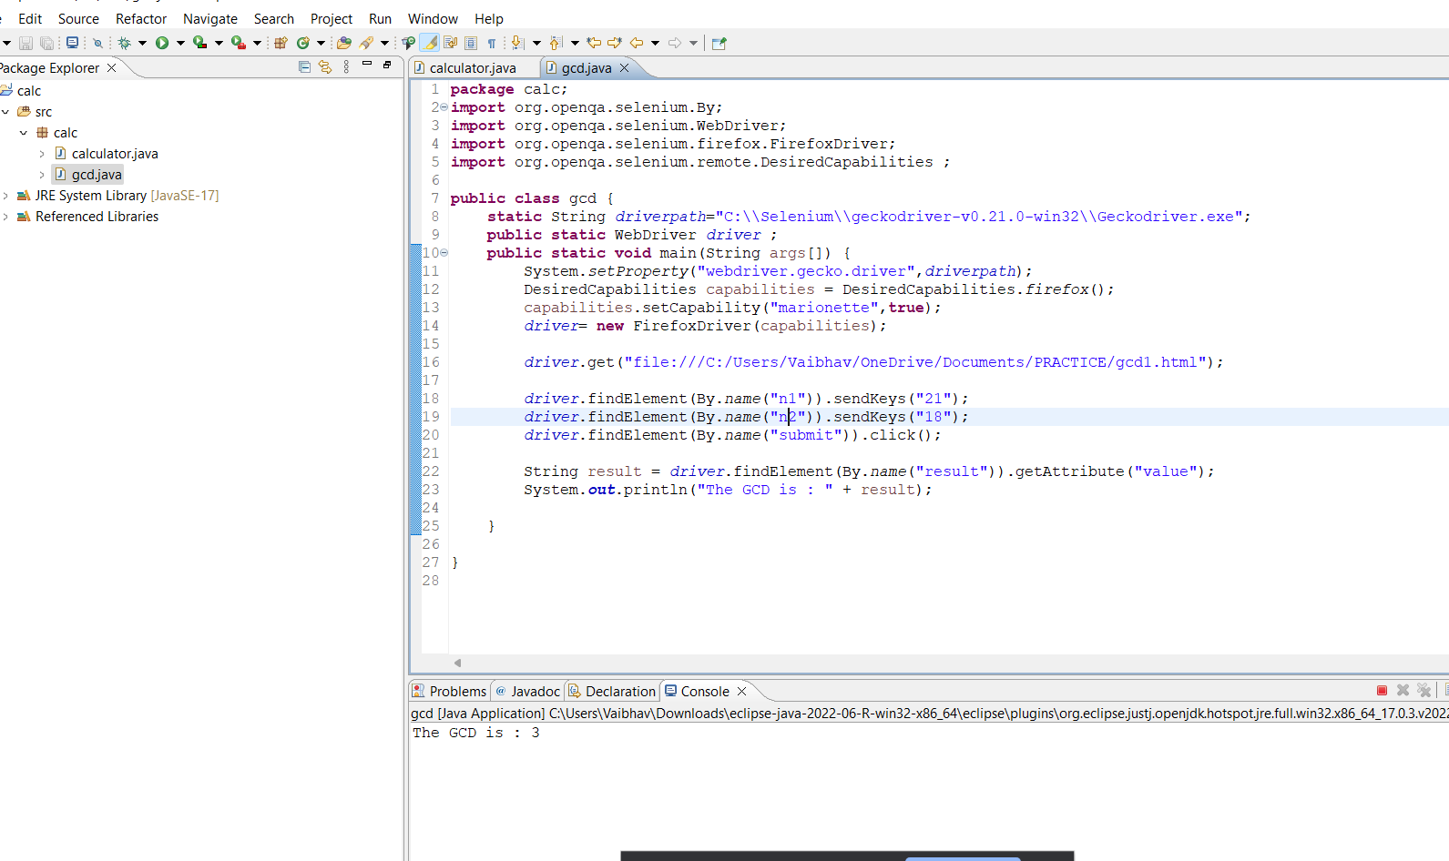

Console



Web Page

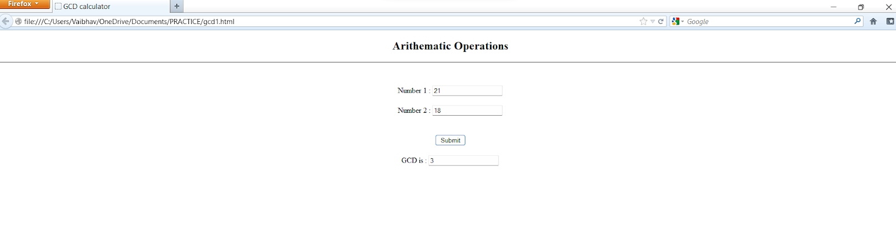

**PRACTICAL 4 : Write and test a program to login a specific web page.**  
  
a. Facebook login  
b. Gmail registration

1. Facebook login

Create java project -> package -> class

Add all external jars

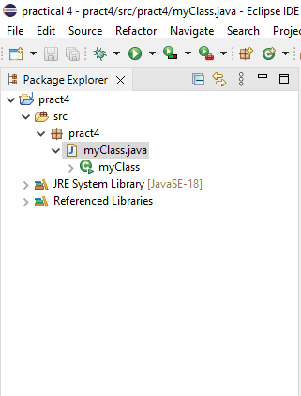

**CODE** :

myClass.java

**package** pract4;

**import** org.openqa.selenium.By;

**import** org.openqa.selenium.WebDriver;

**import** org.openqa.selenium.firefox.FirefoxDriver;

**import** org.openqa.selenium.remote.DesiredCapabilities ;

**public** **class** myClass {

**static** String *driverpath*="C:\\Users\\student\\Downloads\\geckodriver-v0.21.0-win32\\Geckodriver.exe";

**public** **static** WebDriver *driver* ;

**public** **static** **void** main(String args[]) {

System.*setProperty*("webdriver.gecko.driver",*driverpath*);

DesiredCapabilities capabilities = DesiredCapabilities.*firefox*();

capabilities.setCapability("marionette",**true**);

*driver*= **new** FirefoxDriver(capabilities);

*driver*.get("https://www.facebook.com/login/");

*driver*.findElement(By.*id*("email")).sendKeys("shrutikagholap1@gmail.com");

*driver*.findElement(By.*id*("pass")).sendKeys("jd234");

*driver*.findElement(By.*id*("loginbutton")).click();

}

}

Run the java file

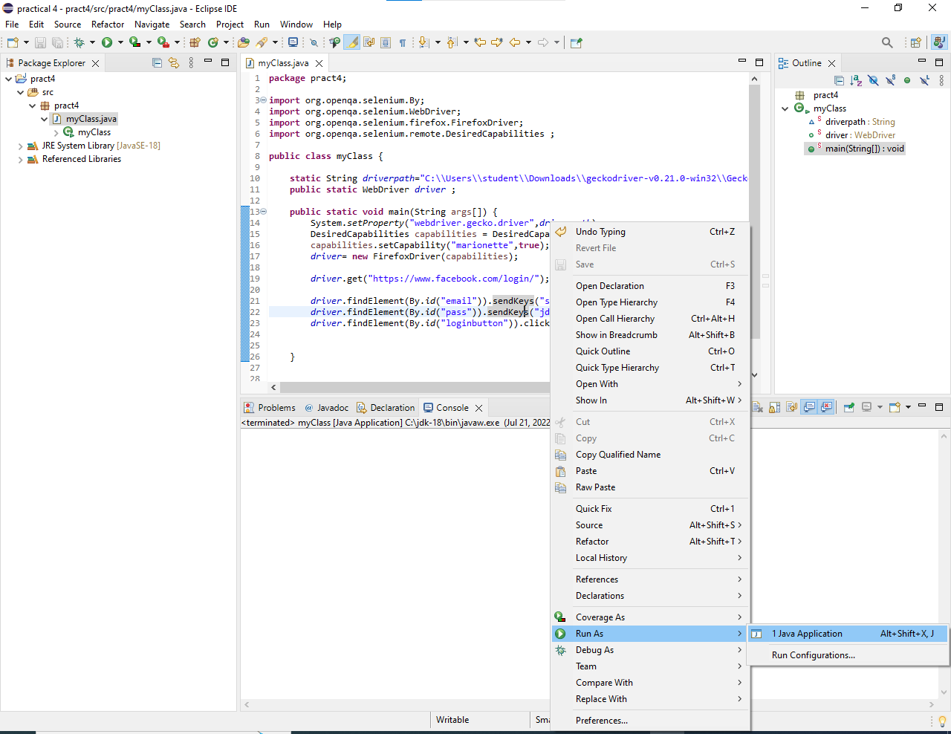

**OUTPUT** :

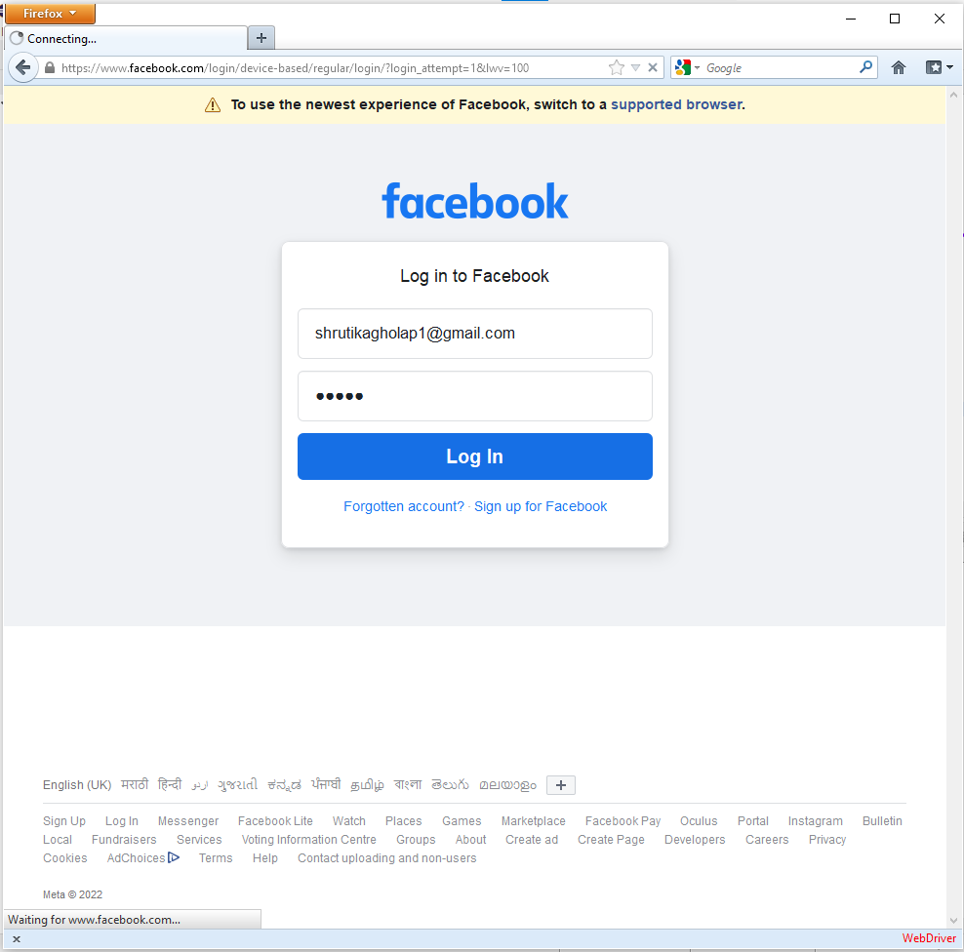

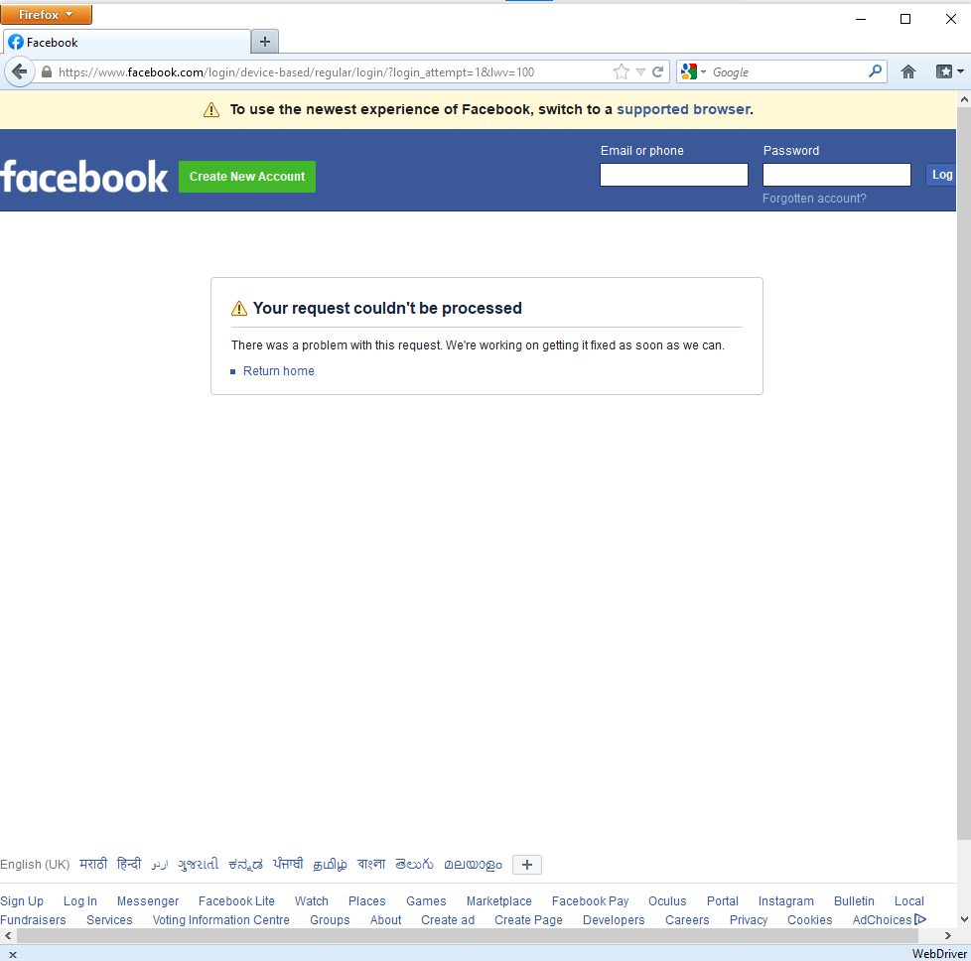

1. Gmail registration

**CODE** :

**package** pract4;

**import** org.openqa.selenium.By;

**import** org.openqa.selenium.WebDriver;

**import** org.openqa.selenium.firefox.FirefoxDriver;

**import** org.openqa.selenium.remote.DesiredCapabilities ;

**public** **class** myClass {

**static** String *driverpath*="C:\\Users\\student\\Downloads\\geckodriver-v0.21.0-win32\\Geckodriver.exe";

**public** **static** WebDriver *driver* ;

**public** **static** **void** main(String args[]) {

System.*setProperty*("webdriver.gecko.driver",*driverpath*);

DesiredCapabilities capabilities = DesiredCapabilities.*firefox*();

capabilities.setCapability("marionette",**true**);

*driver*= **new** FirefoxDriver(capabilities);

*driver*.get("https://accounts.google.com/signup/v2/webcreateaccount?flowName=GlifWebSignIn&flowEntry=SignUp");

*driver*.findElement(By.*name*("firstName")).sendKeys("shruti");

*driver*.findElement(By.*name*("lastName")).sendKeys("gholap");

*driver*.findElement(By.*id*("username")).sendKeys("shruti123");

*driver*.findElement(By.*name*("Passwd")).sendKeys("Shrutika@12");

*driver*.findElement(By.*name*("ConfirmPasswd")).sendKeys("Shrutika@12");

*driver*.findElement(By.*name*("Next")).click();

}

}

**OUTPUT** :

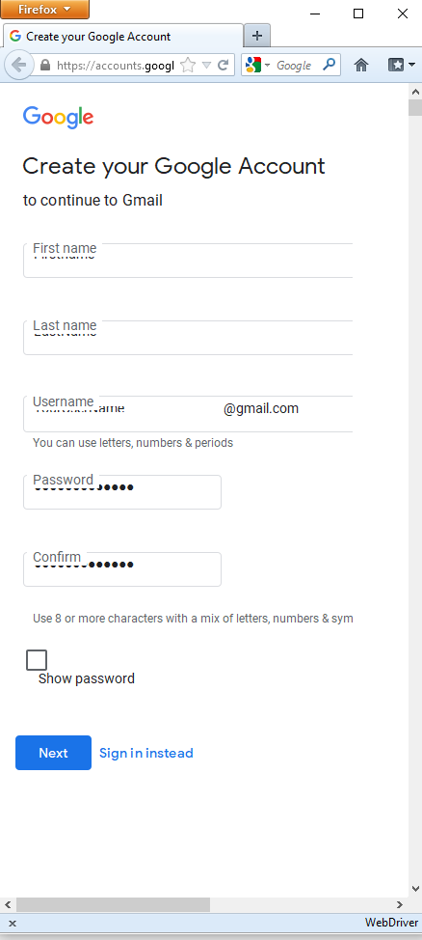

**PRACTICAL 5 : Write and test a program to provide total number of links available on the page.**

**CODE**  :

**package** pract4;

**import** org. openqa.selenium.By ;

**import** org.openqa.selenium.WebDriver;

**import** org.openqa.selenium.WebElement;

**import** org.openqa.selenium.firefox.FirefoxDriver;

**import** org. openqa.selenium.remote.DesiredCapabilities;

**public** **class** myClass {

**static** String *driverPath* = "C:\\Users\\student\\Downloads\\geckodriver-v0.21.0-win32\\GeckoDriver.exe";

**public** **static** WebDriver *driver*;

**public** **static** **void** main(String args[])

{

System.*setProperty*("webdriver.gecko.driver",*driverPath*);

DesiredCapabilities capabilities = DesiredCapabilities.*firefox*();

capabilities.setCapability("marionette",**true**);

*driver*= **new** FirefoxDriver(capabilities);

*driver*.get("https:\\www.ruiacollege.edu");

java.util.List<WebElement> links = *driver*.findElements(By.*tagName*("a"));

System.***out***.println("Total links are"+links.size());

**for** (**int** i =0 ;i<links.size();i=i+1)

{

System.***out***.println("Link " +i+ "Link Name" + links.get(i).getText());

}

}

}

**OUTPUT** :

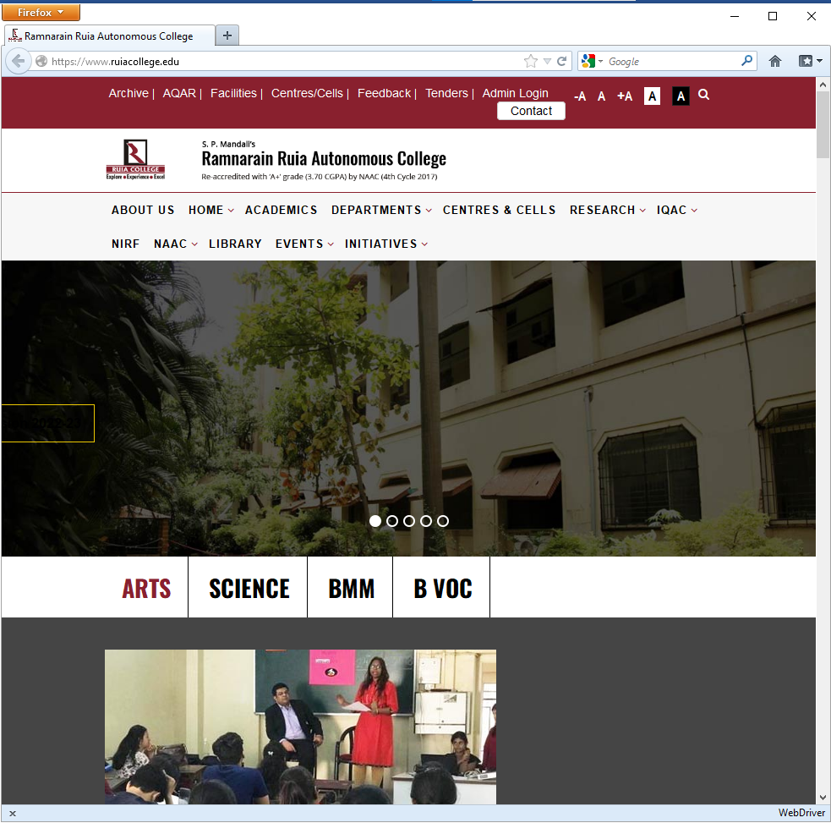

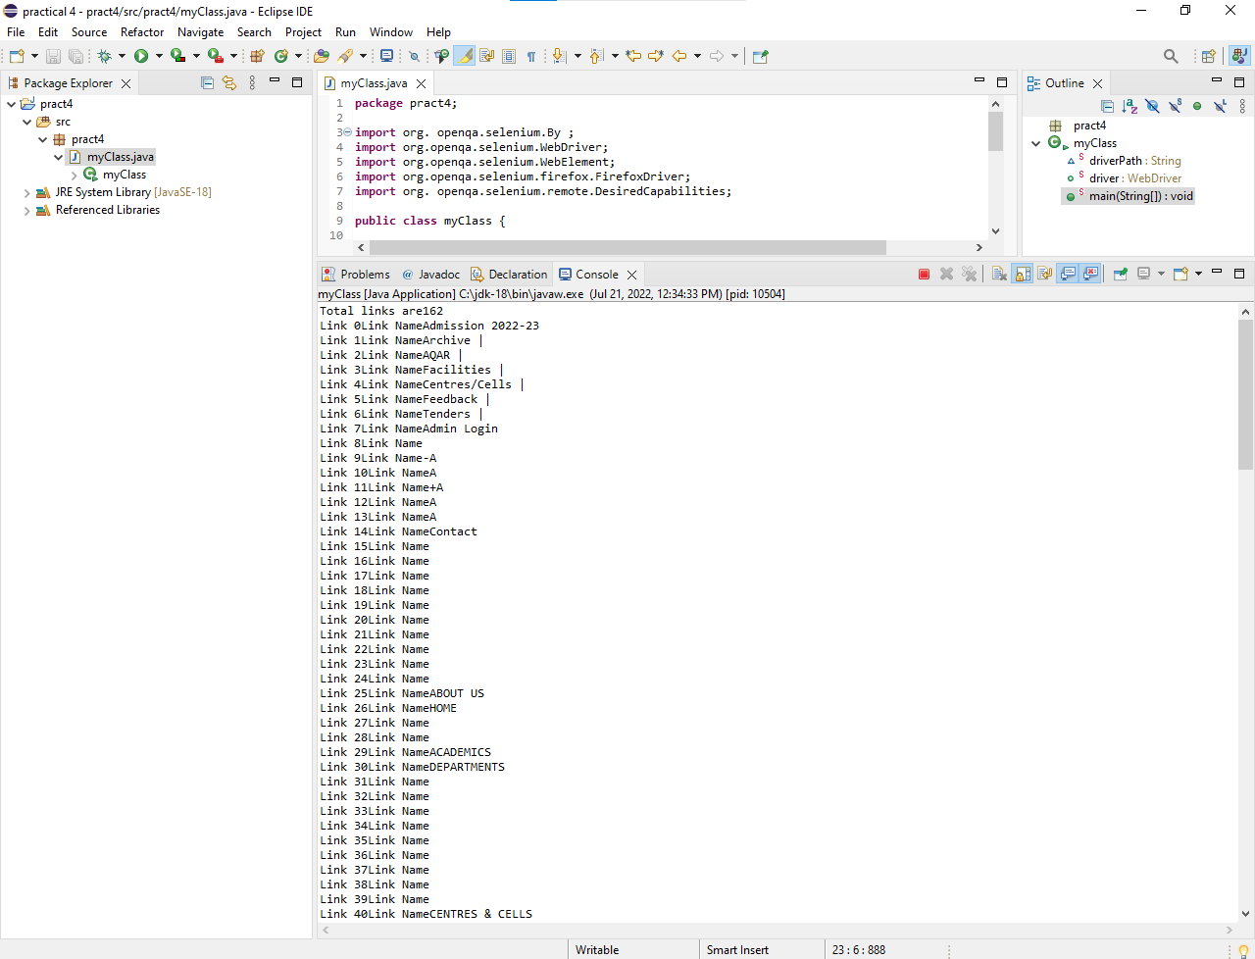

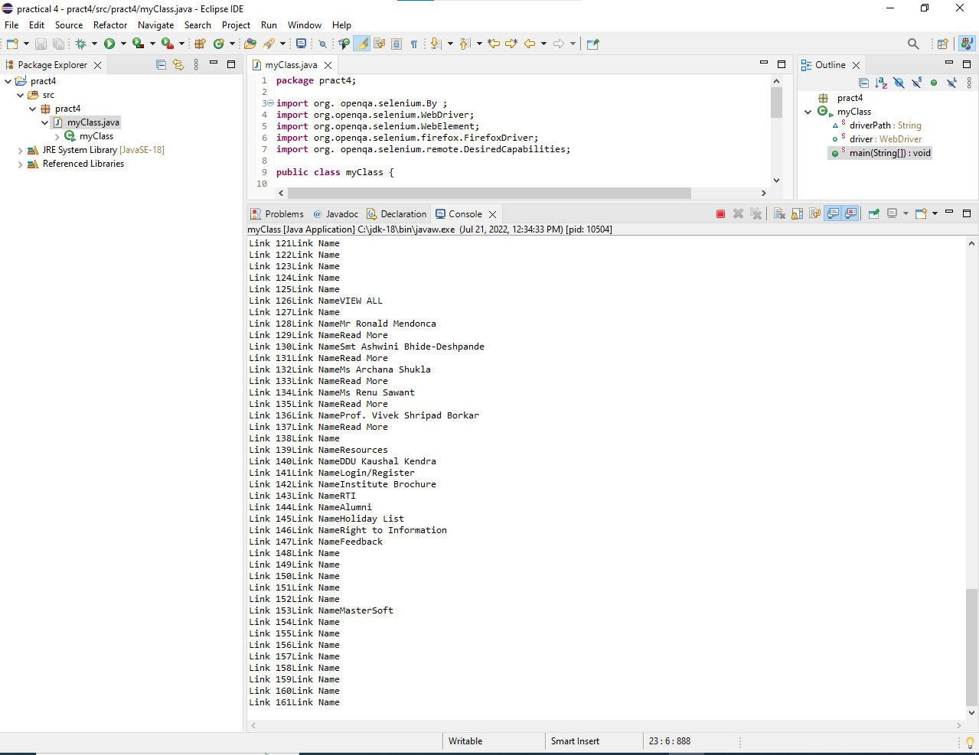

**PRACTICAL 6 : Write and test a program to Create & insert records into table of Excel file.**

Q. Write and test a program to Create & insert 10 student records into table into Excel file.

Create a java project.

Right click on project -> properties

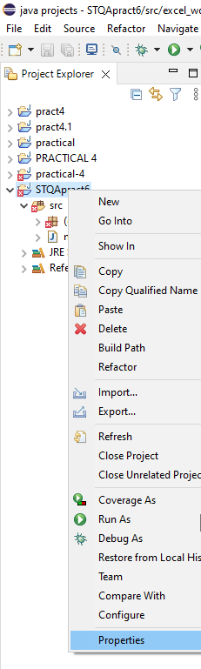

Add external jar file

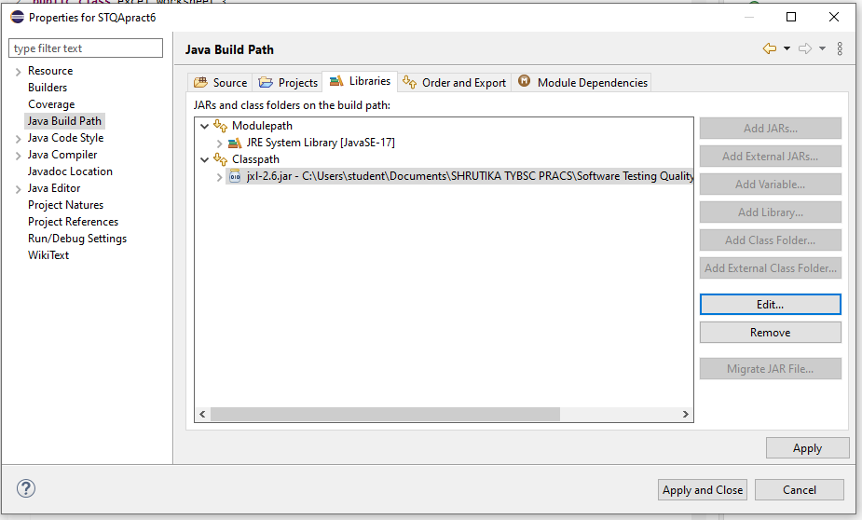

Change version of java compiler

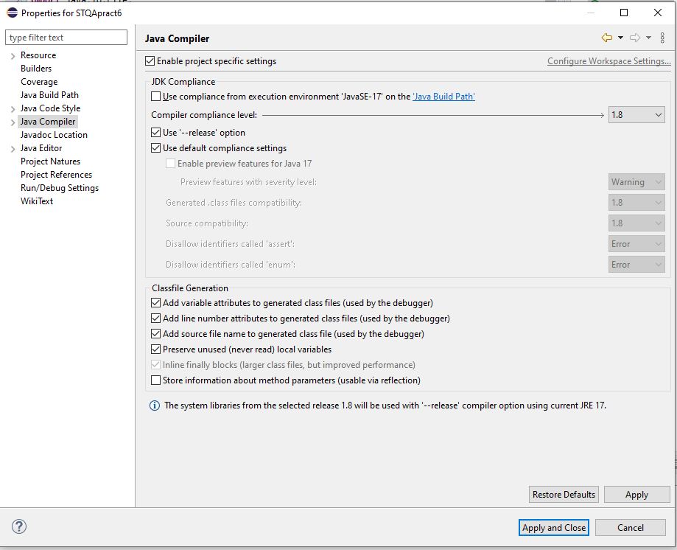

Create a java class

**CODE** :

Excel_worksheet.java

**import** java.io.File;

**import** java.io.IOException;

**import** java.util.Locale;

**import** jxl.CellView;

**import** jxl.Workbook;

**import** jxl.WorkbookSettings;

**import** jxl.format.UnderlineStyle;

**import** jxl.write.Label;

**import** jxl.write.Number;

**import** jxl.write.WritableCellFormat;

**import** jxl.write.WritableFont;

**import** jxl.write.WritableSheet;

**import** jxl.write.WritableWorkbook;

**import** jxl.write.WriteException;

**import** jxl.write.biff.RowsExceededException;

**public** **class** excel_worksheet {

**private** WritableCellFormat timesBoldUnderline;

**private** WritableCellFormat times;

**private** String inputFile;

**public** **void** setOutputFile(String inputFile) {

**this**.inputFile = inputFile;

}

**public** **void** write() **throws** IOException, WriteException {

File file = **new** File(inputFile);

WorkbookSettings wbSettings = **new** WorkbookSettings();

wbSettings.setLocale(**new** Locale("en", "EN"));

WritableWorkbook workbook = Workbook.*createWorkbook*(file, wbSettings);

workbook.createSheet("Report", 0);

WritableSheet excelSheet = workbook.getSheet(0);

createLabel(excelSheet);

createContent(excelSheet);

workbook.write();

workbook.close();

}

**private** **void** createLabel(WritableSheet sheet)

**throws** WriteException {

// Lets create a times font

WritableFont times10pt = **new** WritableFont(WritableFont.***TIMES***, 10);

// Define the cell format

times = **new** WritableCellFormat(times10pt);

// Lets automatically wrap the cells

times.setWrap(**true**);

// Create a bold font with underlines

WritableFont times10ptBoldUnderline = **new** WritableFont(

WritableFont.***TIMES***, 10, WritableFont.***BOLD***, **false**,

UnderlineStyle.***SINGLE***);

timesBoldUnderline = **new** WritableCellFormat(times10ptBoldUnderline);

// Lets automatically wrap the cells

timesBoldUnderline.setWrap(**true**);

CellView cv = **new** CellView();

cv.setFormat(times);

cv.setFormat(timesBoldUnderline);

//cv.setAutosize(true);

// Write a few headers

addCaption(sheet, 0, 0, "Student Name");

addCaption(sheet, 1, 0, "Subject 1");

addCaption(sheet, 2, 0, "subject 2");

addCaption(sheet, 3, 0, "subject 3");

}

**private** **void** createContent(WritableSheet sheet) **throws** WriteException,

RowsExceededException {

// Write a few number

**for** (**int** i = 1; i < 10; i++) {

// First column

addLabel(sheet, 0, i, "Student " + i);

// Second column

addNumber(sheet, 1, i, ((i*i)+10));

addNumber(sheet, 2, i, ((i*i)+4));

addNumber(sheet, 3, i, ((i*i)+3));

}

}

**private** **void** addCaption(WritableSheet sheet, **int** column, **int** row, String s)

**throws** RowsExceededException, WriteException {

Label label;

label = **new** Label(column, row, s, timesBoldUnderline);

sheet.addCell(label);

}

**private** **void** addNumber(WritableSheet sheet, **int** column, **int** row,

Integer integer) **throws** WriteException, RowsExceededException {

Number number;

number = **new** Number(column, row, integer, times);

sheet.addCell(number);

}

**private** **void** addLabel(WritableSheet sheet, **int** column, **int** row, String s)

**throws** WriteException, RowsExceededException {

Label label;

label = **new** Label(column, row, s, times);

sheet.addCell(label);

}

**public** **static** **void** main(String[] args) **throws** WriteException, IOException {

excel_worksheet test = **new** excel_worksheet();

test.setOutputFile("C:\\Users\\student\\Desktop\\a.xls");

test.write();

System.***out***.println("Please check the result file under C:\\Users\\student\\Desktop\\a.xls ");

}

}

**OUTPUT :**

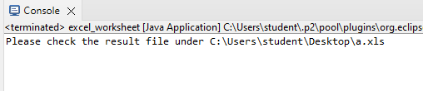

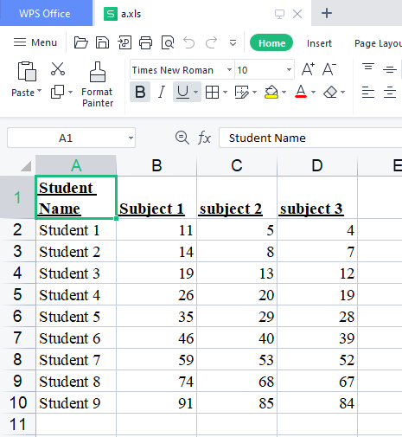

**PRCATICAL 7**

Q. Write and test a program to Create & insert 10 student records into table into Excel file.

Create a java project.

Right click on project -> properties

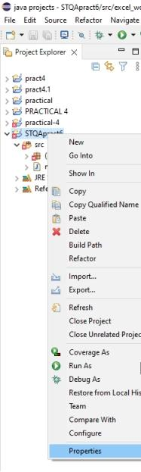

Add external jar file

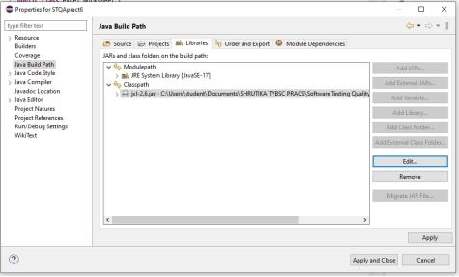

Change version of java compiler

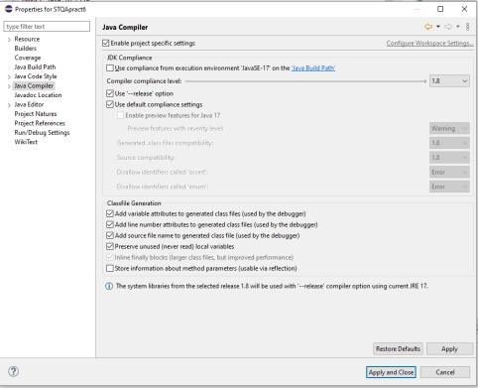

Create a java class

**CODE** :

Student_excel_sheet.java

**import** java.io.File;

**import** java.io.IOException;

**import** jxl.Cell;

**import** jxl.CellType;

**import** jxl.Sheet;

**import** jxl.Workbook;

**import** jxl.read.biff.BiffException;

**public** **class** student_excel_sheet {

**private** String inputFile;

**public** **void** setInputFile(String inputFile) {

**this**.inputFile = inputFile;

}

**public** **void** read() **throws** IOException{

File inputWorkbook = **new** File(inputFile);

Workbook w;

**boolean** flag = **false**;

**int** count =0;

**try** {

w = Workbook.*getWorkbook*(inputWorkbook);

// get first sheet

Sheet sheet = w.getSheet(0);

// Loop over first 10 cols and lines

**for**(**int** j=0; j<sheet.getRows(); j++) {

**for**(**int** i=0; i<sheet.getColumns(); i++) {

Cell cell = sheet.getCell(i, j);

**if**(cell.getType()==CellType.***NUMBER***) {

**if**(Integer.*parseInt*(cell.getContents())>60) {

flag = **true**;

**if**(flag == **true**) {

count++;

flag = **false**;

}

**break**;

}

}

}

}

System.***out***.println("Total number of students who scored more than 60 in any subject is : "+count);

}**catch**(BiffException e) {

e.printStackTrace();

}

}

**public** **static** **void** main(String[] args) **throws** IOException{

student_excel_sheet test = **new** student_excel_sheet();

test.setInputFile("C:\\Users\\student\\Desktop\\a.xls");

test.read();

}

}

**OUTPUT :**

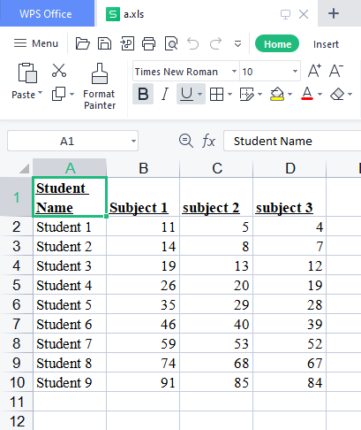

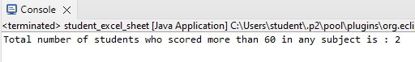

**PRACTICAL 8 :**

Q. Write and test a program to count the number of check boxes on the page checked and unchecked count.

**CODE:**

**package** check_un_Pract8;

**import** org.openqa.selenium.By;

**import** org.openqa.selenium.WebDriver;

**import** org.openqa.selenium.WebElement;

**import** org.openqa.selenium.chrome.ChromeDriver;

**public** **class** check_uncheck {

**public** **static** **void** main(String[] args) {

     // declaration and instantiation of objects/variables

        System.*setProperty*("webdriver.chrome.driver","C:\\Users\\student\\Downloads\\chromedriver.exe");

        WebDriver driver = **new** ChromeDriver();

        String baseUrl = "http://demo.guru99.com/test/login.html";

        driver.get(baseUrl);

        // Get the WebElement corresponding to the Email Address(TextField)

        WebElement email = driver.findElement(By.*id*("email"));

        // Get the WebElement corresponding to the Password Field

        WebElement password = driver.findElement(By.*name*("passwd"));

        email.sendKeys("abcd@gmail.com");

        password.sendKeys("abcdefghlkjl");

        System.***out***.println("Text Field Set");

        // Deleting values in the text box

        email.clear();

        password.clear();

        System.***out***.println("Text Field Cleared");

        // Find the submit button

        WebElement login = driver.findElement(By.*id*("SubmitLogin"));

        // Using click method to submit form

        email.sendKeys("abcd@gmail.com");

        password.sendKeys("abcdefghlkjl");

        login.click();

        System.***out***.println("Login Done with Click");

        //using submit method to submit the form. Submit used on password field

        driver.get(baseUrl);

        driver.findElement(By.*id*("email")).sendKeys("abcd@gmail.com");

        driver.findElement(By.*name*("passwd")).sendKeys("abcdefghlkjl");

        driver.findElement(By.*id*("SubmitLogin")).submit();

        System.***out***.println("Login Done with Submit");

        driver.get("http://demo.guru99.com/test/radio.html");

        WebElement radio1 = driver.findElement(By.*id*("vfb-7-1"));

        WebElement radio2 = driver.findElement(By.*id*("vfb-7-2"));

        //Radio Button1 is selected

        radio1.click();

        System.***out***.println("Radio Button Option 1 Selected");

        //Radio Button1 is de-selected and Radio Button2 is selected

        radio2.click();

        System.***out***.println("Radio Button Option 2 Selected");

        // Selecting CheckBox

        WebElement option1 = driver.findElement(By.*id*("vfb-6-0"));

        // This will Toggle the Check box

        option1.click();

        // Check whether the Check box is toggled on

**if** (option1.isSelected()) {

            System.***out***.println("Checkbox is Toggled On");

        } **else** {

            System.***out***.println("Checkbox is Toggled Off");

        }

        //Selecting Checkbox and using isSelected Method

        driver.get("http://demo.guru99.com/test/facebook.html");

        WebElement chkFBPersist = driver.findElement(By.*id*("persist_box"));

**for** (**int** i=0; i<2; i++) {

            chkFBPersist.click ();

            System.***out***.println("Facebook Persists Checkbox Status is -  "+chkFBPersist.isSelected());

        }

//driver.close();

}

}

**OUTPUT:**

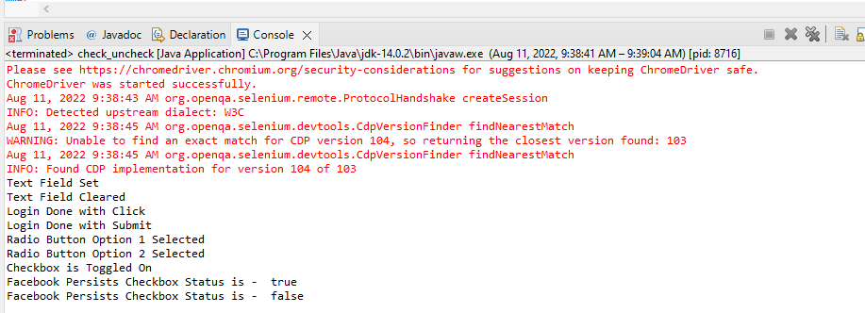

**PRACTICAL 9 : Write and test a program to get the number of items in a list / combo box.**

Q. Write and test a program to get the number of items in a list / combo box.

**CODE:**

Combocount.html

<html>

<head>

<title>Select Example by Index value</title>

</head>

<body>

<select id="Mobiles"><option value="0" selected> Please select</option>

<option value="1">iPhone</option>

<option value="2">Nokia</option>

<option value="3">Samsung</option>

<option value="4">HTC</option>

<option value="5">BlackBerry</option>

<option value="6">BlackBerry</option>

<option value="7">BlackBerry</option>

<option value="8">BlackBerry</option>

<option value="9">BlackBerry</option>

</select>

<select id="Mobiless" size="6" multiple><option value="0" selected> Please select</option>

<option value="1">iPhone</option>

<option value="2">Nokia</option>

<option value="3">Samsung</option>

<option value="4">HTC</option>

</select>

</body>

</html>

Count_dropdown.java

**package** pract_9;

**import** java.util.List;

**import** org.openqa.selenium.By;

**import** org.openqa.selenium.WebDriver;

**import** org.openqa.selenium.WebElement;

**import** org.openqa.selenium.firefox.FirefoxDriver;

**import** org.openqa.selenium.support.ui.Select;

**public** **class** count_dropdown {

**public** **static** **void** main(String[] args) {

        //Define the Webdriver for Browser i.e. Firefox

System.*setProperty*("webdriver.gecko.driver", "C:\\Users\\student\\Tejas_4825\\Software testing and quality assurance\\geckodriver-v0.31.0-win64\\geckodriver.exe");

        WebDriver driver = **new** FirefoxDriver();

        //Open the URL (Website)

        driver.get("C:\\Users\\student\\Tejas_4825\\Software testing and quality assurance\\combocount.html");

        //Assign and Select the dropdown list element

        // Select selectDropdown = new Select(driver.findElement(By.id("Mobiles")));

        Select selectDropdown = **new** Select(driver.findElement(By.*id*("Mobiless")));

        //Get all the option from dropdown list and assign into List

        List<WebElement> listOptionDropdown = selectDropdown.getOptions();

        // Count the item dropdown list and assign into integer variable

**int** dropdownCount = listOptionDropdown.size();

        //Print the total count of dropdown list using integer variable

        System.***out***.println("Total Number of item count in dropdown list = "  + dropdownCount);

 }

}

**OUTPUT:**

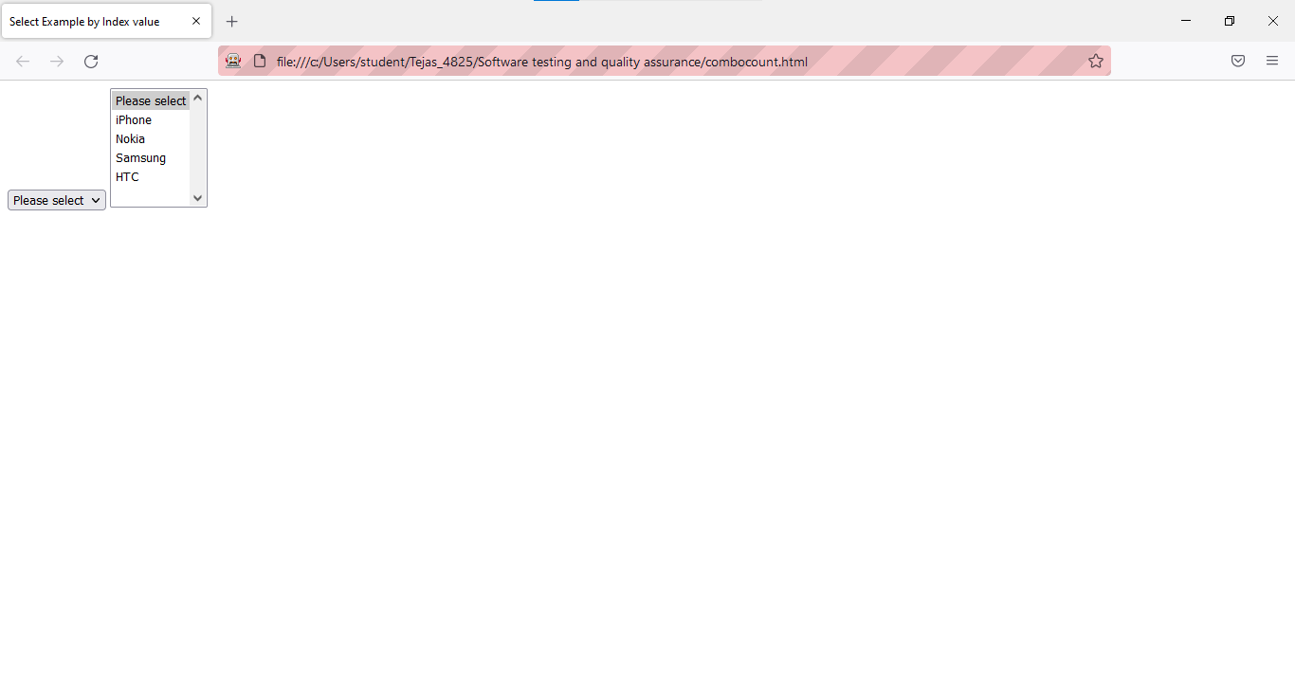

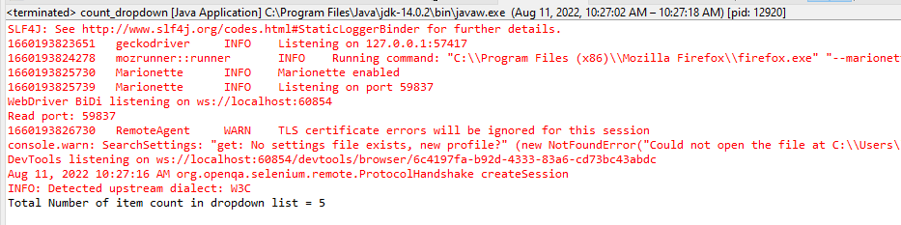

**PRACTICAL 10 : Write and test a program using Selenium Webdriver To Select Value from DropDown**

Q. :  Write and test a program using Selenium Webdriver To Select Value from DropDown.

**CODE:**

Combocount.html

<html>

<head>

<title>Select Example by Index value</title>

</head>

<body>

<select id="Mobiles"><option value="0" selected> Please select</option>

<option value="1">iPhone</option>

<option value="2">Nokia</option>

<option value="3">Samsung</option>

<option value="4">HTC</option>

<option value="5">BlackBerry</option>

<option value="6">BlackBerry</option>

<option value="7">BlackBerry</option>

<option value="8">BlackBerry</option>

<option value="9">BlackBerry</option>

</select>

<select id="Mobiless" size="6" multiple><option> Please select</option>

<option value="1">iPhone</option>

<option value="2">Nokia</option>

<option value="3">Samsung</option>

<option value="4">HTC</option>

</select>

</body>

</html>

Count_dropdown.java

**package** pract_10;

**import** java.util.List;

**import** org.openqa.selenium.By;

**import** org.openqa.selenium.WebDriver;

**import** org.openqa.selenium.WebElement;

**import** org.openqa.selenium.firefox.FirefoxDriver;

**import** org.openqa.selenium.support.ui.Select;

**public** **class** select_dropdown {

**public** **static** **void** main(String[] args) {

        //Define the Webdriver for Browser i.e. Firefox

System.*setProperty*("webdriver.gecko.driver", "C:\\Users\\student\\Tejas_4825\\Software testing and quality assurance\\geckodriver-v0.31.0-win64\\geckodriver.exe");

        WebDriver driver = **new** FirefoxDriver();

        //Open the URL (Website)

        driver.get("C:\\Users\\student\\Tejas_4825\\Software testing and quality assurance\\combocount.html");

        //Assign and Select the dropdown list element

        // Select selectDropdown = new Select(driver.findElement(By.id("Mobiles")));

        Select selectDropdown = **new** Select(driver.findElement(By.*id*("Mobiless")));

        selectDropdown.selectByVisibleText("Samsung");

        selectDropdown.selectByIndex(2);

        String s= selectDropdown.toString();

        System.***out***.println("Total Number of item count in dropdown list = "  + selectDropdown);

 }

}

**OUTPUT:**

